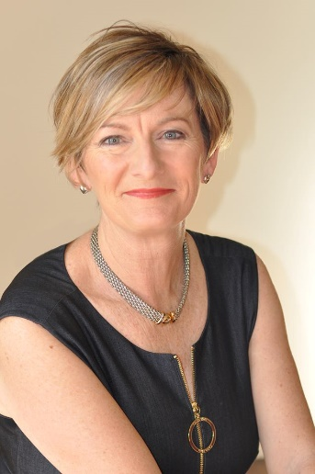
This is Louise's 15th year operating Global People Two – a leadership practice which finds her working with people to develop their leadership skills. She helps people understand their own and others’ personality, their own emotional intelligence, the effect of their conversational style on others and how to build the capability and confidence of their team to create effective workplaces and communities.
Louise worked in the '80s, 90's and into the new millennium in the finance sector. Her corporate experience included stints in Banking, Sales & Marketing, Learning & Education, Project Management, with her final role being the Head of Operations for Credit Risk Management. Louise didn’t have the ‘Credit’ expertise to be the 2IC; she was recruited to influence people to become part of the culture change.
During 2018, Louise coached and mentored many individuals and teams in their leadership pursuits; she designed and delivered leadership programs and workshops in the health sector, local and state government, book publishing, building and automobile industries and her most enjoyable time was spent working with high performing teams to achieve more results through more effective relationships.
She is married with two children in high school, is an avid walker and golfer and enjoys a good champagne shared with friends.
Qualifications
- Diploma in Applied Languages (Japanese)
- Diploma in Education & Training
- Cert IV Training & Assessment

Instrument Accreditations
- CoreStrengths - Values, Motives, Strengths, Conflict, Overdone Strengths, 360 Feedback
- Strengths Deployment Inventory (SDI) - Relationship Awareness Theory
- DiSC

Experience
- Operated Leadership Consultancy Practice Global People Two for 14 years
- Co-Founder / Co-Facilitator - Driving Your Life - Personal Leadership program
- Board Director - Australian Junior Chamber (1997), Junior Chamber International (1999), Melbourne CBD Small Business Incubator (2002)
- Key-Note Speaker - Australia, Asia, USA
- Senior Business Leader, National Australia Bank (1999 - 2004)
- Founder - Sandhurst Women’s Business Network (250 membres)

